Chapter 6A: Classic Bluetooth – The Wireless Serial Port Profile (SPP)

Time: 3 ¾ Hours

At the end of this chapter you will understand the basics of Classic Bluetooth and how to create a simple Classic Bluetooth project on WICED devices. This section is focused on the simplest Bluetooth connection, one Master (Android, Mac or PC) and one Slave (your WICED Bluetooth Device). By the end you should understand Inquiry, Page, Pair, Bond, SDP, L2CAP, RFCOMM and the Serial Port Profile (SPP).

6A.1 WICED Bluetooth Classic System Lifecycle Overview 2

6A.1.1 Inquiry 3

6A.1.2 Page / Connect 4

6A.1.3 Pair & Bond 4

6A.1.4 Discover the Services using Service Discovery Protocol (SDP) 4

6A.1.5 Exchange Data with the Serial Port Profile 5

6A.2 Secure Simple Pairing 5

6A.3 Service Discovery Protocol (SDP) 5

6A.4 L2CAP, RFCOMM & the Serial Port Profile 6

6A.4.1 L2CAP 6

6A.4.2 RFCOMM 7

6A.4.3 Serial Port Profile 7

6A.5 WICED Bluetooth Designer 7

6A.5.1 WICED Studio 6.2 – BT Designer Bugs 13

6A.6 WICED Bluetooth Stack Events 14

6A.7 WICED Classic Bluetooth Firmware Architecture 15

6A.7.1 Overview 15

6A.7.2 Application Code (<appname>.c) 15

6A.7.3 SDP Database (<appname>_sdb_db.c/.h) 16

6A.7.4 Handle Pairing 17

6A.7.5 Handle Bonding 18

6A.7.6 Support the Serial Port Profile 19

6A.8 Exercises 24

Exercise - 6A.1 Create a Serial Port Profile Project 24

Exercise - 6A.2 Add UART Transmit 36

Exercise - 6A.3 (Advanced) Improve Security by Adding IO Capabilities (Yes/No) 37

Exercise - 6A.4 (Advanced) Add Multiple Device Bonding Capability 38

# WICED Bluetooth Classic System Lifecycle Overview

The Bluetooth Classic Spec has a bewildering amount of complexity. Clearly this must have been one of the motivations for creating the much simpler BLE standard. Like Chapter 4 we will take the approach of creating the simplest example project possible to get things going.

The simplest Bluetooth Classic scenario has two devices, a Master and a Slave. Slaves are passive – not transmitting – until they hear an Inquiry broadcast from a Master, at which point the Slave broadcasts basic information about itself (Name, BDADDR, Services). The Master then Pages (connects) to the Slave and they exchange and save Pairing information. The Master then discovers the Services - i.e. the capabilities of the Slave. Finally, a basic wireless Serial Port data exchange connection is created.

The five steps are:

1. Inquiry – Master finds a Slave to Connect
2. Paging – Master connects to Slave
3. Pair & Bond – A secure, authenticated connection is created
4. Service Discovery (SDP) – The Master figures out what the Slave can do
5. Exchange Data using the Serial Port Profile

The architecture of a Bluetooth Classic device is essentially the same as that of a BLE device. It is composed of the same four layers.

|  |  |  |
| --- | --- | --- |
|  | Application | The code that you write to implement your system functionality. |
| Bluetooth Classic Stack | Host | Provides multiple connection paths to the application each with its own properties (reliable, ordered, time critical, etc.). It also provides Services to the local and remote application. |
| Controller | Establishes and maintain links between devices. |
| Hardware | Radio | RF magic & the best reason to use Cypress chips. |

Here is the overall picture of the simplest Bluetooth Classic system:



## Inquiry

The purpose of the Inquiry process is for a Bluetooth Master to find all the Bluetooth Slaves that are within its radio range that might provide some interesting Service. This is exactly the opposite of BLE where a Peripheral advertises it availability and the BLE Central Scans for those packets.

A Bluetooth Classic Slave sits in state called Inquiry Scan - i.e. a listening only state - until it hears a Bluetooth Master broadcast an Inquiry Request message. The Slave Application is responsible for putting the Stack into the Inquiry Scan state using the correct Stack API.

Upon hearing an Inquiry Request the Slave will broadcast an Extended Inquiry Response (EIR) packet that contains its Name, Bluetooth Address (BDADR) and list of Services. These responses are handled completely by the Controller part of the Stack - i.e. your Application is not aware of these Inquiry Requests happening.

You should be aware that because of the vagaries of the Bluetooth Radio frequency hopping scheme, these Inquires make take up to 10ish seconds.

## Page / Connect

The Paging process is used for a Bluetooth Master to connect to a Bluetooth Slave. The Master is "paging" the Slave device (remember the old school [pagers](https://www.youtube.com/watch?v=l7Og1DuMu3k&list=RDl7Og1DuMu3k&t=18)?).

A Bluetooth Classic Slave sits in state called Page Scan - i.e. a listening only state - until a Bluetooth Master initiates the connection process by sending a Page Request. The Slave is responsible for putting the Stack into the Page Scan state using the correct Stack API.

A Slave can - and often will be - in both the Page Scan and Inquiry Scan modes at the same time, meaning a Master can initiate a connection to a Slave without Inquiring if it already knows of the existence of the Slave from a previous connection.

## Pair & Bond

The whole Bluetooth communication system depends on having a shared symmetric encryption key called the Link Key. Bluetooth Classic uses a process called Secure Simple Pairing that exchanges enough information for the Link Key to be created. (There are other legacy Pairing methods, but they are largely obsolete at this point).

The Secure Simple Pairing process was designed to minimize the chances that the communication link could be compromised by an eavesdropper or by a man-in-the-middle. The process is the same as the BLE process minus the Numeric Comparison method.

As with BLE, Bonding is just saving the BDADR/Link Key into non-volatile memory so that it can be reused to speed up re-initiating a connection.

I'll talk about this process in more detail in a minute in section 6A.2

## Discover the Services using Service Discovery Protocol (SDP)

A simple conceptual model of a Bluetooth Classic device is a Server that is running one or more Services that are attached to Ports. This is the same model that we use in IP Networking.

One question that arises from this idea is: "How do I figure out what Services are available and what Port they are listening on?". The answer to both questions is the Service Discovery Protocol.

The SDP has a database embedded in it that contains a list of Services and what Port each one is running on. The SDP Protocol allows the Bluetooth Master to query the SDP database.

More details on this in section 6A.3

## Exchange Data with the Serial Port Profile

Once Service Discovery is complete, the Bluetooth Master knows the Port number that it should use to connect to the Serial Port Profile (SPP). The SPP is just one of these Servers (from the last section) that acts like a serial port. You put bytes in one side and they come out the other.

The Bluetooth Master then opens a connection to the SPP Server running on the Bluetooth Slave. At this point you can commence the final step in your first basic project: actually exchanging data.

Again, we'll talk about this in much more detail in section 6A.4

# Secure Simple Pairing

Secure Simple Pairing is the same Pairing technique that we used in the BLE (except that the PIN is typically 4 digits instead of 6). You use a PIN code which is either:

1. Some trivial fixed value like '0000' or '1234' if you have no I/O capability
2. Displayed on one side, then entered on the other
3. Transmitted out of band (OOB), for example, using NFC

The PIN is then used to encrypt and transmit random numbers which are generated on both side of the connection.

Finally, the Pin + Random Numbers + some data about the device are combined into a Link Key which serves as a shared secret to identify and encrypt data between the devices.

# Service Discovery Protocol (SDP)

From the Bluetooth Core Spec – "The service discovery protocol (SDP) provides a means for Applications to discover which Services are available and to determine the characteristics of those available services." The SDP sits on top of the L2CAP layer – and when communicating generates a bunch of L2CAP traffic.

The Bluetooth SIG specifies the SDP database format in Volume 3 Part B of the Bluetooth Core Spec. The database is composed of one or more Service Records each containing one or more Service Attributes. Each Service Attribute is a Key/Value pair. There are several Bluetooth SIG Specified Service Attributes, but you can also create custom Attributes.

Some of the legal Attributes include:

ServiceRecordHandle – A 32-bit number uniquely identifying that Service in the SDP.

ServiceClassIDList – Identifies what type of Service this record represents, specifically a list of classes of Service.

ProtocolDescriptorList – A list of the protocol stacks that may be used to access this Service.

ServiceName – A plain text description of the Service.

The SDP provides the means for the Client to Search for Services and Attributes and request the values of the same.

# L2CAP, RFCOMM & the Serial Port Profile­­­

The Bluetooth Classic system has a stack of software and hardware built into it. For the purposes of this simple Bluetooth Classic example, three blocks in the Host are relevant: L2CAP, RFCOMM and the Serial Port Profile.

You can see the three blocks in this simplified diagram of the Stack.

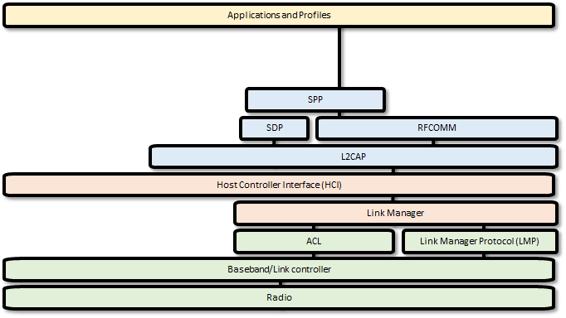

## L2CAP

L2CAP is an acronym that stands for Logical Link Control and Adaptation-layer Protocol. L2CAP has one main function in the system: it serves as a data packet multiplexor that lets you have multiple streamed connections from the higher level going into one interlaced set of packets going out the Radio. It obviously implements the de-multiplexor function as well, taking a single stream of interlaced packets and turning it back into complete streams on the other side of the link.

The L2CAP divides up the streams of data into L2CAP Channels that:

1. Divides up streams of data into smaller packets that will fit through the Radio.
2. Provides quality of service to each of the L2CAP channels.
3. Provides flow control.

## RFCOMM

RFCOMM was built as a wired RS232 replacement protocol. It supports all the normal wires for a serial port including Rx, Tx, CTS, RTS, DSR, DTR, CD and Ri. Depending on the implementation, RFCOMM gives you up to 60 Server Channels of streams of serial data. The protocol is built on top of L2CAP (a packet-based system). It appears to the Application developer with an API that makes it look like a UART.

## Serial Port Profile

The Serial Port Profile specifies all the protocols and procedures required to setup, discover and connect two virtual serial ports over an RFCOMM connection.

FYI, for iOS devices, the SPP is locked so it is only usable for MFi license holders. Their implementation is called iAP2.

# WICED Bluetooth Designer

As with BLE, WICED Bluetooth Designer can be used to help you create a WICED Bluetooth Classic Project. Specifically, it will help you:

* Make a template project with all the required files
* Create the SDP Database
* Create a Make Target

To run the tool, go to File 🡪 New 🡪 WICED Bluetooth Designer

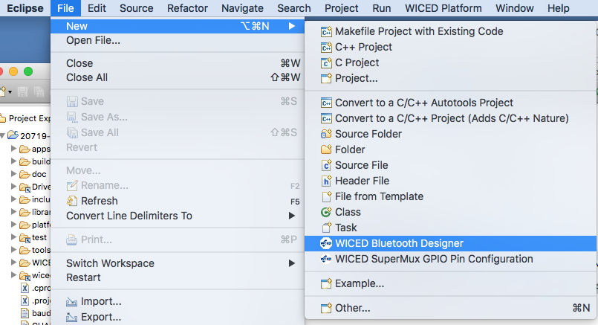

Give your project a name, in this case I call it "key_ClassicSpp". **When you do this yourself, be sure to make the name unique so that you will be able to identify which device is yours. For example, <inits>_ClassicSpp where <inits> is your initials.**

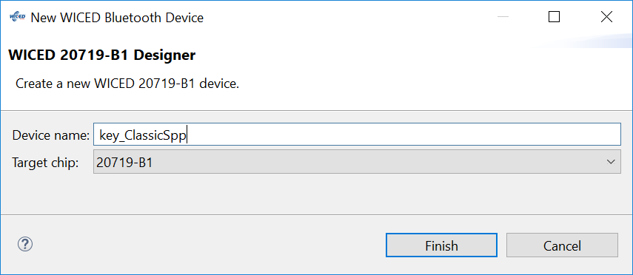

Click "Finish" to open the configuration window.

The default setting is Single Mode LE, but we want a Bluetooth Classic BR/EDR project so change the Bluetooth Mode to "Single Mode BR/EDR".

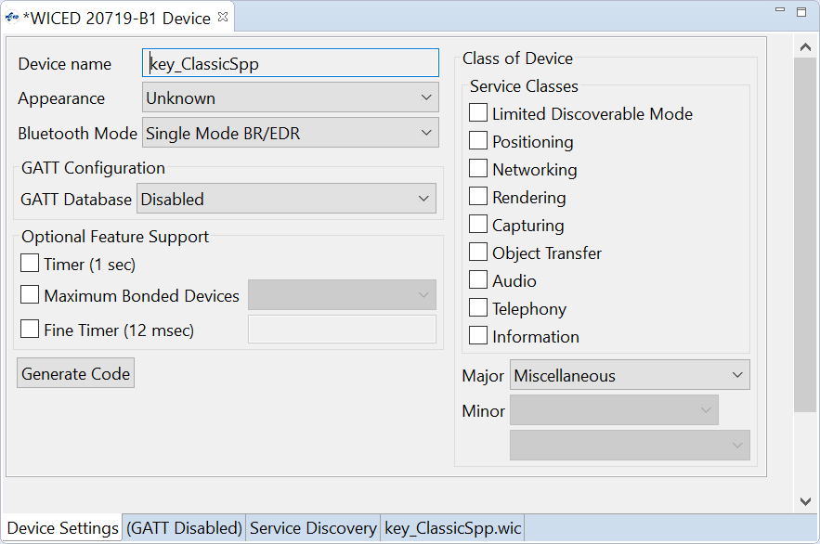

The biggest benefit of Bluetooth Designer is helping you build the "Service Discovery" database. Click on the Service Discovery Tab at the bottom of the window.

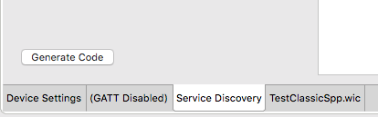

The SDP database starts with nothing in it. To add Services to the database, click on the drop-down menu under "Add SDP Service", pick out the Service you want (in this case, Serial Port) then click "+".

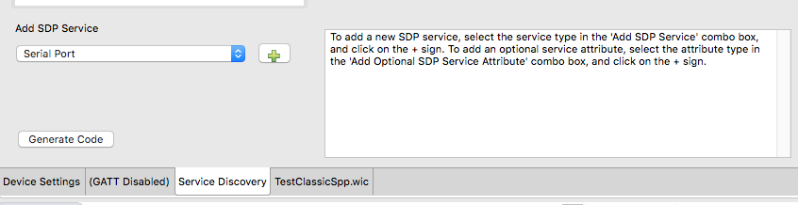

Now the SDP Database (which shows up in the window titled SDP Services) has the Serial Port. Click on the Arrow to the left of "Serial Port" to expand the Attributes that are created for the SPP:

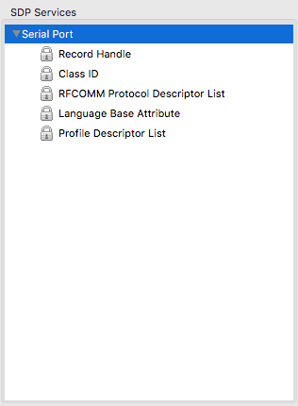­­

By default, the "Service Name" and "Browse List" are not included in the Attributes for the SPP. To add them, select them from the "Add Optional SDP Service Attribute" menu and press the "+". Here I add the "Service Name":

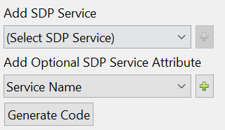

Next, I'll change the name to "SPP Service" by typing in the "Service Name" text box.

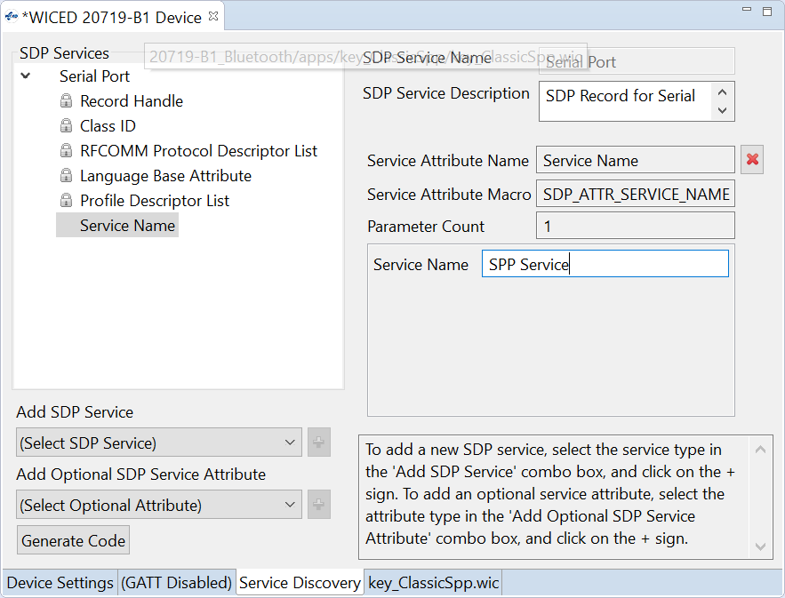

To add the Browse List to the SPP Service, select "Browse List" from the Optional SDP Service Attribute List and press "+".

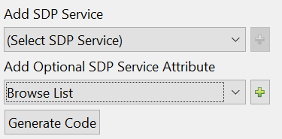

I'll leave the settings for the Browse List at the default values.

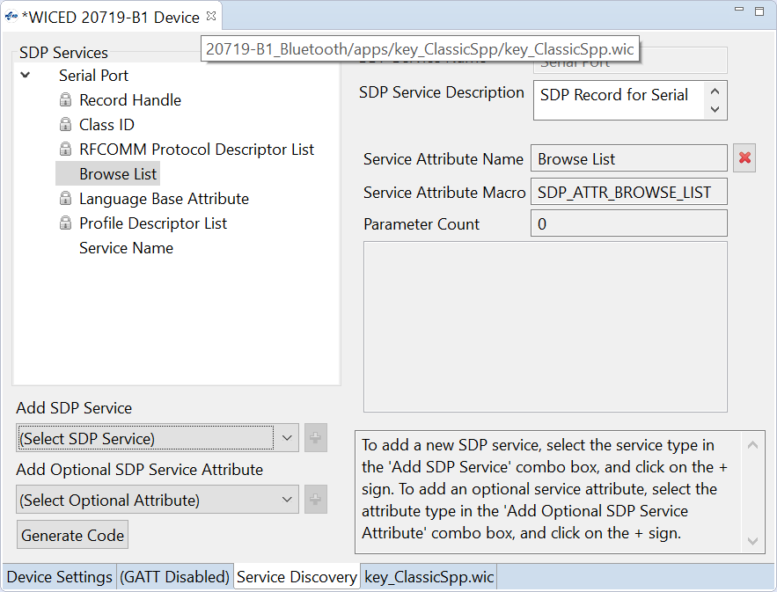

This completes the setup for the SPP service.

Next, I'll add another Service to the Database called the Device ID Service. This contains things like vendor ID, product ID, etc. which you can use to convey information about your device.

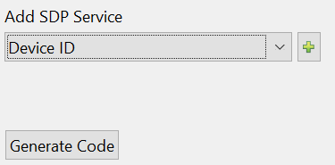

After it is added, you can see all the Attributes that go with it. You can change some of the values by clicking on the Attribute you want to modify and then entering the new values. Only certain values are editable. **The default value for Vendor ID is 0xFFFF. This is not a valid vendor ID, so it will not work properly in all situations. Therefore, you MUST change this to a valid Vendor ID. In this case, I'll use the Cypress Vendor ID which is 0x0131.**

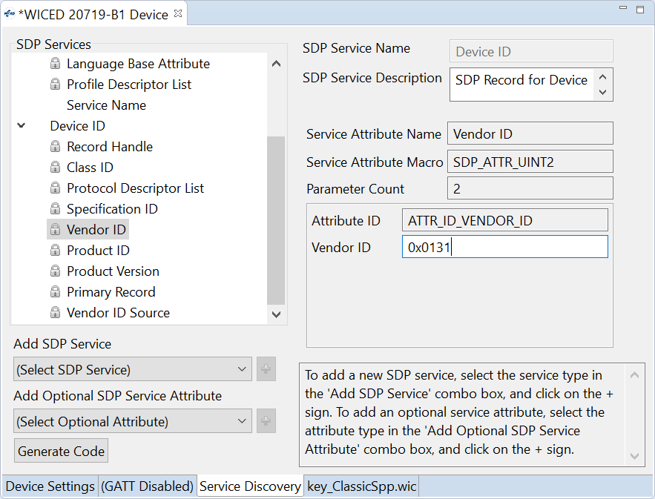

The last step in the process of generating the project is to press the Generate Code button which will create the project with C-code that you will customize later, and it will create a make target.

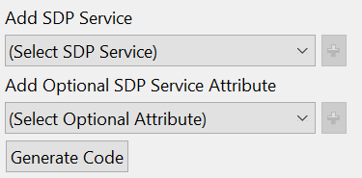

Here is the resulting workspace:

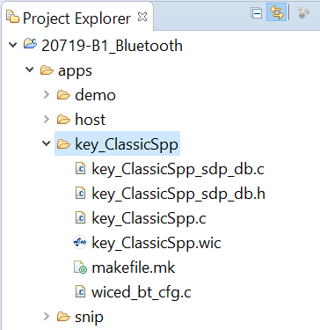

WICED Bluetooth Designer also creates a Make Target for your new project but it does not include the options BT_DEVICE_ADDRESS=random. I'll add that now so that I don't end up with a conflicting address.

I will also change the platform name to use the kit/shield combination platform.

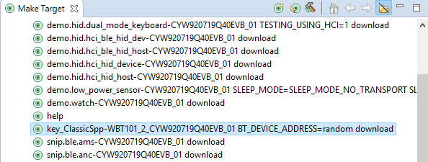

## WICED Studio 6.2 – BT Designer Bugs

In WICED Studio 6.2, BT Designer generates projects with missing includes. To get rid of these warnings you will need to add the following to <inits>_ClassicSpp.c:

#include "wiced_bt_stack.h"

#include "wiced_bt_sdp.h"

#include "wiced_hal_wdog.h"

#include "wiced_bt_app_common.h"

# WICED Bluetooth Stack Events

The Stack generates Events based on what is happening in the Bluetooth world. After an event is created, the Stack will call the callback function which you registered when you turned on the Stack. Your callback firmware must look at the event code and the event parameter and take the appropriate action.

For your Basic Application these are the relevant BTM Events:

|  |  |
| --- | --- |
| **Event** | **Description** |
| BTM_ENABLED_EVT | When the Stack has everything going. This event data will tell if you it happened with WICED_SUCCESS or !WICED_SUCCESS. This is typically where you will launch most of your application code. |
| BTM_SECURITY_REQUEST_EVT | For BLE, this is used to retrieve the local identity key for RPA. For Classic BT you don't need to do anything for this event. |
| BTM_PAIRING_IO_CAPABILITIES_BR_EDR_REQUEST_EVT | The Stack is asking what IO capabilities this device has (Display, Keyboard etc.). You need to update the structure sent to you in the event data. |
| BTM_PAIRING_COMPLETE_EVT | The Stack is informing you that you are now paired. |
| BTM_ENCRYPTION_STATUS_EVT | The Stack is informing you that the link is now encrypted…or not depending on the event data. |
| BTM_PAIRED_DEVICE_LINK_KEYS_REQUEST_EVT | The Stack is asking you find and return the link key for the BDADDR that was sent in the event data. |
| BTM_USER_CONFIRMATION_REQUEST_EVT | The Stack is asking you to ask the user if the PIN you are displaying matches the PIN from the other side. |
| BTM_LOCAL_IDENTITY_KEYS_REQUEST_EVT | The Stack is asking you to read the local identify keys from the NVRAM and return them to the Stack. |
| BTM_PAIRING_IO_CAPABILITIES_BR_EDR_RESPONSE_EVT | The Stack is informing you of the I/O capabilities of the other side of the connection. |
| BTM_PAIRED_DEVICE_LINK_KEYS_UPDATE_EVT | The Stack is asking your firmware to store the BDADDR/Link Keys (which are passed in the event data). |

# WICED Classic Bluetooth Firmware Architecture

## Overview

WICED Bluetooth Designer will create a skeleton of the firmware that you need start building your device. The skeleton includes:

1. A file named <appname>.c which contains the application functions:
   1. *application_start* which is the entry point for the firmware.
   2. *<appname>_app_init* which provides a place for you to get your application stuff going.
   3. *<appname>_management_callback* which is a template BTM event handler function.
2. A .c/.h pair of files called <appname>_sdp_db.c/.h containing:
   1. The #defines for the SDP database.
   2. A uint8_t structure holding the actual database.
3. A file called wiced_bt_config.h containing:
   1. All the basic Bluetooth configuration settings to get the stack going.

## Application Code (<appname>.c)

As mentioned above, the application_start function is the entry point of the firmware. By default, that function will:

* Initialize the memory pools (just like BLE)
* Configure the debugging UART if you want WICED_BT_TRACE messages
* Call wiced_bt_stack_init with the event handler to start the stack

The <appname>_app_init function is created for you as a place to initialize your application. It is called in the BTM event handler after the stack starts. By default, this function:

* Makes your device pairable
* Initializes the SDP database
* Makes your device connectable (turns on Paging)
* Makes your device discoverable (turns on Inquiry)

To make your project work you need to add the capability to <appname>.c to:

* Handle Pairing
* Handle Bonding
* Support the Serial Port Profile

These will each be covered in detail in a minute.

You also should change the code to route the debug messages to the PUART (i.e. uncomment the line to use WICED_ROUTE_DEBUG_TO_PUART and comment the line to use WICED_ROUTE_DEBUG_TO_WICED_UART).

## SDP Database (<appname>_sdb_db.c/.h)

The Service Discovery Database is created for you based on the configuration settings in BT Designer. It creates the files <appname>_sdp_db.c/.h

The file <appname>_sdp_db.h for the simple project with the SPP and Device ID Services that we created using BT Designer is shown here:

**#ifndef** __SDP_DATABASE_H__

**#define** __SDP_DATABASE_H__

// SDP Record for Serial Port

**#define** HDLR_SERIAL_PORT 0x10001

**#define** SERIAL_PORT_SCN 0x01

// SDP Record for Device ID

**#define** HDLR_DEVICE_ID 0x10002

// External definitions

**extern** **const** uint8_t sdp_database[];

**extern** **const** uint16_t sdp_database_len;

**#endif** /* __SDP_DATABASE_H__ */

The file <appname>_sdp_db.c simply contains the two Service Records that we defined in BT Designer: the SPP and the Device Info.

**const** uint8_t sdp_database[] = // Define SDP database

{

SDP_ATTR_SEQUENCE_1(157),

// SDP Record for Serial Port

SDP_ATTR_SEQUENCE_1(84),

SDP_ATTR_RECORD_HANDLE(HDLR_SERIAL_PORT),

SDP_ATTR_CLASS_ID(UUID_SERVCLASS_SERIAL_PORT),

SDP_ATTR_RFCOMM_PROTOCOL_DESC_LIST(SERIAL_PORT_SCN),

SDP_ATTR_BROWSE_LIST,

SDP_ATTR_LANGUAGE_BASE_ATTR_ID_LIST,

SDP_ATTR_PROFILE_DESC_LIST(UUID_SERVCLASS_SERIAL_PORT, 0x0102),

SDP_ATTR_SERVICE_NAME(11),

'S', 'P', 'P', ' ', 'S', 'e', 'r', 'v', 'i', 'c', 'e',

// SDP Record for Device ID

SDP_ATTR_SEQUENCE_1(69),

SDP_ATTR_RECORD_HANDLE(HDLR_DEVICE_ID),

SDP_ATTR_CLASS_ID(UUID_SERVCLASS_PNP_INFORMATION),

SDP_ATTR_PROTOCOL_DESC_LIST(1),

SDP_ATTR_UINT2(ATTR_ID_SPECIFICATION_ID, 0x103),

SDP_ATTR_UINT2(ATTR_ID_VENDOR_ID, 0x0131),

SDP_ATTR_UINT2(ATTR_ID_PRODUCT_ID, 0xFFFF),

SDP_ATTR_UINT2(ATTR_ID_PRODUCT_VERSION, 0xFFFF),

SDP_ATTR_BOOLEAN(ATTR_ID_PRIMARY_RECORD, 0x01),

SDP_ATTR_UINT2(ATTR_ID_VENDOR_ID_SOURCE, DI_VENDOR_ID_SOURCE_BTSIG),

};

// Length of the SDP database

const uint16_t sdp_database_len = sizeof(sdp_database);

The sequence numbers that you see above (SDP_ATTR_SEQUENCE) indicate the length of the database items. For example, 157 is the total number of bytes in the database (excluding itself). Likewise, 84 is the total number of bytes in the SPP service (again excluding itself).

The only action required by your application firmware to interact with the database is to register it. This is inserted into the function <appname>_app_init for you automatically by BT Designer:

/* Initialize SDP Database */

wiced_bt_sdp_db_init( (uint8_t*)sdp_database, sdp_database_len );

## Handle Pairing

In the file <appname>.c you need to add code to handle pairing since it is not done completely by WICED Bluetooth Designer.

The BTM events involved in Pairing are:

* BTM_PAIRING_IO_CAPABILITIES_BR_EDR_RESPONSE_EVT
* BTM_PAIRING_IO_CAPABILITIES_BR_EDR_REQUEST_EVT
* BTM_USER_CONFIRMATION_REQUEST_EVT
* BTM_PAIRING_COMPLETE_EVT

When the Master attempts to Pair with you, it sends its I/O capabilities. When you get that event, you can decide what to do including nothing. In this case, we just print out the I/O capabilities. By default, BT Designer does not include this event in the template.

**case** *BTM_PAIRING_IO_CAPABILITIES_BR_EDR_RESPONSE_EVT*:

WICED_BT_TRACE(

"IO_CAPABILITIES_BR_EDR_RESPONSE peer_bd_addr: %B, peer_io_cap: %d, peer_oob_data: %d, peer_auth_req: %d\n",

p_event_data->pairing_io_capabilities_br_edr_response.bd_addr,

p_event_data->pairing_io_capabilities_br_edr_response.io_cap,

p_event_data->pairing_io_capabilities_br_edr_response.oob_data,

p_event_data->pairing_io_capabilities_br_edr_response.auth_req);

**break**;

When you get the event asking for your I/O Capabilities, you need to respond by changing the event data. By default, BT Designer gives you an incomplete filling of the structure. You need to add the local IO capabilities. For example, if your device has a display but no user entry, you would use BTM_IO_CAPABILITIES_DISPLAY_ONLY as shown here:

**case** *BTM_PAIRING_IO_CAPABILITIES_BR_EDR_REQUEST_EVT*:

/* Request for Pairing IO Capabilities (BR/EDR) */

WICED_BT_TRACE("BR/EDR Pairing IO Capabilities Request\n");

p_event_data->pairing_io_capabilities_br_edr_request.oob_data = *BTM_OOB_NONE*;

p_event_data->pairing_io_capabilities_br_edr_request.auth_req = *BTM_AUTH_SINGLE_PROFILE_GENERAL_BONDING_YES*;

p_event_data->pairing_io_capabilities_br_edr_request.is_orig = WICED_FALSE;

p_event_data->pairing_io_capabilities_br_edr_request.local_io_cap = *BTM_IO_CAPABILITIES_DISPLAY_ONLY*;

**break**;

When the pairing process is complete you can print a message (BT Designer does this for you by default), or more likely initialize some variable for that session (which you would have to do yourself).

**case** *BTM_PAIRING_COMPLETE_EVT*:

/* Pairing is Complete */

p_br_edr_info = &p_event_data->pairing_complete.pairing_complete_info.br_edr;

WICED_BT_TRACE("Pairing Complete %d.\n", p_br_edr_info->status);

**break**;

## Handle Bonding

As with Paring, the code to handle Bonding must be added to <appname>.c.

To handle Bonding, you need to act on the BTM Events that request you to find the saved link key for a specific BD Address (BTM_PAIRED_DEVICE_LINK_KEYS_REQUEST_EVT) and to save the Link Key when it is created or updated for a specific address (BTM_PAIRED_DEVICE_LINK_KEYS_UPDATE_EVT).

This is best done by reserving a block of the NVRAM VSIDs to hold the key/BDADDR tuple. The VSID is just a row number in the NVRAM. Each Volatile Sector in the NVRAM is 255 bytes long. Each WICED Device has #defines for the WICED_NVRAM_VSID_START and WICED_NVRAM_VSID_END in wiced_hal_nvram.h.

BT Designer provides a template for the keys request event. To enable it you just need to change the #if value from 0 to 1. You will also need to provide the function <appname>_read_link_keys which we will do in a minute.

**case** *BTM_PAIRED_DEVICE_LINK_KEYS_REQUEST_EVT*:

/* Paired Device Link Keys Request */

WICED_BT_TRACE("Paired Device Link Request Keys Event\n");

/* Device/app-specific **TODO**: HANDLE PAIRED DEVICE LINK REQUEST KEY - retrieve from NVRAM, etc */

**#if** 1

**if** (key_classicspp_read_link_keys( &p_event_data->paired_device_link_keys_request ))

{

WICED_BT_TRACE("Key Retrieval Success\n");

}

**else**

**#endif**

/* Until key retrieval implemented above, just fail the request - will cause re-pairing */

{

WICED_BT_TRACE("Key Retrieval Failure\n");

status = *WICED_BT_ERROR*;

}

**break**;

BT Designer does not provide a template for the keys update event. So, you need to add the case for that event, which simply calls a write function that we will create next.

**case** *BTM_PAIRED_DEVICE_LINK_KEYS_UPDATE_EVT*:

WICED_BT_TRACE("BTM_PAIRED_DEVICE_LINK_KEYS_UPDATE_EVT\n");

key_classicspp_write_link_keys(&p_event_data->paired_device_link_keys_update);

**break**;

Next, you need to write the <appname>_read_link_keys and <appname>_write_link_keys functions. In our case we will write them so that they each support only one set of saved link keys, and they each use an entire VSID row.

// This function reads the first VSID row into the link keys

**int** **key_classicspp_read_link_keys**( wiced_bt_device_link_keys_t *keys )

{

wiced_result_t result;

**int** bytes_read;

bytes_read = wiced_hal_read_nvram(*WICED_NVRAM_VSID_START*,**sizeof**(wiced_bt_device_link_keys_t),

(uint8_t *)keys,&result);

WICED_BT_TRACE("NVRAM ID:%d read :%d bytes result:%d\n", *WICED_NVRAM_VSID_START*, bytes_read, result);

**return** bytes_read;

}

// This function write the link keys into the first VSID row

**int** **key_classicspp_write_link_keys**( wiced_bt_device_link_keys_t *keys )

{

wiced_result_t result;

**int** bytes_written = wiced_hal_write_nvram(*WICED_NVRAM_VSID_START*, **sizeof**(wiced_bt_device_link_keys_t),

(uint8_t*)keys, &result);

WICED_BT_TRACE("NVRAM ID:%d written :%d bytes result:%d\n", *WICED_NVRAM_VSID_START*, bytes_written, result);

**return** (bytes_written);

}

After you write these two functions you need to add a forward declaration for each of them at the top of the file.

**int** **key_classicspp_read_link_keys**( wiced_bt_device_link_keys_t *keys );

**int** **key_classicspp_write_link_keys**( wiced_bt_device_link_keys_t *keys );

## Support the Serial Port Profile

To make the SPP work you need to initialize the server and provide callbacks for starting and stopping the connection and for receiving data. The WICED Bluetooth SDK contains all the code to implement an SPP server in two places: (1) the low-level functions are in a library called "spp_lib" and; (2) an example application that demonstrates how to use the SPP library functions is in apps/snip/bt/spp.

After you have created your SPP project with the BT Designer tool, you can open snip/bt/spp/spp.c example to copy the additional blocks of code that you need. Typically, I create separate files spp.h and spp.c in my project to handle all the SPP server functionality.

Note: If you don't see snip/bt/spp in your workspace, follow these steps:

1. In the Project Explorer window, right click on "snip" and select New -> Folder.
2. Click the "Advanced >>" button.
3. Select "Link to alternate location (Linked Folder)".
4. Click the "Browse…" button.
5. Navigate to the WICED Studio Installation location (e.g. <User>/Documents/WICED-Studio-<version>) and select the folder "…/common/apps/snip/bt". The window should look like this:

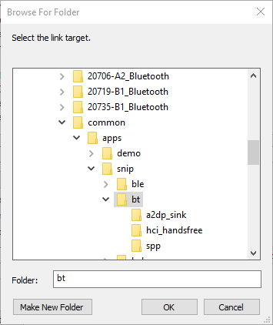

1. Click on "OK".
2. Click on "Finish".

### makefile.mk

There are two changes that need to happen to the file makefile.mk. First, you need to add spp_lib.a so that you can link the SPP library functions. Second, when you add new source files to your project (like spp.c) you need to add them to makefile.mk as well:

**APP_SRC** = key_ClassicSpp.c

**APP_SRC +**= key_ClassicSpp_sdp_db.c

**APP_SRC +**= wiced_bt_cfg.c

**APP_SRC +**= spp.c

**C_FLAGS +**= -DWICED_BT_TRACE_ENABLE

# If defined, HCI traces are sent over transport/WICED HCI interface

**C_FLAGS +**= -DHCI_TRACE_OVER_TRANSPORT

**$(NAME)_COMPONENTS :**= spp_lib.a

### spp.h

Create a new file in the project folder called spp.h. In that file, I just add the *#pragma once* and then provide a function prototype for the public interface to the server:

**#pragma** ONCE

**void** **spp_start**();

### spp.c

Create another new file in the project folder called spp.c. First, I'll add the *#defines* that are needed to get access to the required functions:

In spp.c you first need add #includes to get all the required functions and #defines for some SPP parameters:

**#include** "spp.h"

**#include** "wiced.h"

**#include** "stddef.h"

**#include** "bt_types.h"

**#include** "wiced_bt_spp.h"

**#include** "wiced_bt_trace.h"

**#define** SPP_RFCOMM_SCN (1)

**#define** MAX_TX_BUFFER (1017)

Next you need to include forward declarations for the SPP handler functions that we will write in a minute.

**static** **void** **spp_connection_up_callback**(uint16_t handle, uint8_t* bda);

**static** **void** **spp_connection_down_callback**(uint16_t handle);

**static** wiced_bool_t **spp_rx_data_callback**(uint16_t handle, uint8_t* p_data, uint32_t data_len);

Then you declare a variable called spp_handle to hold the current handle of the SPP connection and a structure of type wiced_bt_spp_reg_t called spp_reg which holds all the configuration information for the SPP Server.

**static** uint16_t spp_handle;

wiced_bt_spp_reg_t spp_reg =

{

SPP_RFCOMM_SCN, /* RFCOMM service channel number for SPP connection */

MAX_TX_BUFFER, /* RFCOMM MTU for SPP connection */

spp_connection_up_callback, /* SPP connection established */

NULL, /* SPP connection establishment failed, not used because

this app never initiates connection */

NULL, /* SPP service not found, not used because this app never

initiates connection */

spp_connection_down_callback, /* SPP connection disconnected */

spp_rx_data_callback, /* Data packet received */

};

Then write a function to startup the SPP server. It just needs to call the startup function from the library with the configuration structure you defined above.

**void** **spp_start**()

{

// Initialize SPP library

wiced_bt_spp_startup(&spp_reg);

}

The connection up and down callbacks send information via the BT Trace and set/unset a global variable that keeps track of the SPP handle.

/*

* SPP connection up callback

*/

**static** **void** **spp_connection_up_callback**(uint16_t handle, uint8_t* bda)

{

WICED_BT_TRACE("%s handle:%d address:%B\n", __FUNCTION__, handle, bda);

spp_handle = handle;

}

/*

* SPP connection down callback

*/

**static** **void** **spp_connection_down_callback**(uint16_t handle)

{

WICED_BT_TRACE("%s handle:%d\n", __FUNCTION__, handle);

spp_handle = 0;

}

When you receive data just dump it out onto the screen in the RX data callback.

/*

* Process data received over EA session. Return TRUE if we were able to allocate buffer to

* deliver to the host.

*/

**static** wiced_bool_t **spp_rx_data_callback**(uint16_t handle, uint8_t* p_data, uint32_t data_len)

{

**int** i;

// wiced_bt_buffer_statistics_t buffer_stats[4];

// wiced_bt_get_buffer_usage (buffer_stats, sizeof(buffer_stats));

// WICED_BT_TRACE("0:%d/%d 1:%d/%d 2:%d/%d 3:%d/%d\n", buffer_stats[0].current_allocated_count, buffer_stats[0].max_allocated_count,

// buffer_stats[1].current_allocated_count, buffer_stats[1].max_allocated_count,

// buffer_stats[2].current_allocated_count, buffer_stats[2].max_allocated_count,

// buffer_stats[3].current_allocated_count, buffer_stats[3].max_allocated_count);

// wiced_result_t wiced_bt_get_buffer_usage (&buffer_stats, sizeof(buffer_stats));

WICED_BT_TRACE("%s handle:%d len:%d %02x-%02x\n", __FUNCTION__, handle, data_len, p_data[0], p_data[data_len - 1]);

**for**(i=0;i<data_len;i++)

WICED_BT_TRACE("%c",p_data[i]);

WICED_BT_TRACE("\n");

**#if** LOOPBACK_DATA

wiced_bt_spp_send_session_data(handle, p_data, data_len);

**#endif**

**return** WICED_TRUE;

}

Note that the implementation above does not send data – it is RX only – but if you look at the #if LOOPBACK_DATA directive you can see how data can be sent using the wiced_bt_spp_send_session_data function. That function can be called anywhere in your application to send data over the SPP interface. It needs the handle to the SPP service, a pointer to the data to send, and the length of the data in bytes. Since it requires the handle, it is easiest to include an additional function (e.g. spp_send_tx_data) in spp.c/.h as part of the public interface so that it has access to the spp_handle variable that we created earlier.

### <appname>.c

In the main application, you need to add an include for spp.h:

**#include** "spp.h"

Then you need to initialize and start the SPP server at the end of the <appname>_app_init function:

/* Start the SPP server */

spp_start();

### wiced_bt_cfg.c

The last thing we need to do is to increase the buffer pool sizes. This is necessary because the SPP uses more memory than is allocated by BT Designer, so it will not work with the default values.

**const** wiced_bt_cfg_buf_pool_t wiced_bt_cfg_buf_pools[WICED_BT_CFG_NUM_BUF_POOLS] =

{

/* { buf_size, buf_count, }, */

{ 64, 16, }, /* Small Buffer Pool */

{ 272, 8, }, /* Medium Buffer Pool (used for HCI & RFCOMM control messages, min recommended size is 360) */

{ 1056, 3, }, /* Large Buffer Pool (used for HCI ACL messages) */

{ 1056, 2, }, /* Extra Large Buffer Pool (used for SDP Discovery) */

};

# Exercises

* 1. Create a Serial Port Profile Project

### Project Creation

For this example, you will need to:

1. Follow the instructions in section 6A.5 to create a new project using BT Designer.
2. Update the project to handle pairing as documented in section 6A.7.4
3. Update the project to handle bonding as documented in section 6A.7.5
4. Update the project with the SPP functionality as documented in section 6A.7.6

Hint: Remember to use your initials in the project name (i.e. device name) so that you can find it in the list of devices that will be advertising.

Hint: Remember to add the option BT_DEVICE_ADDRESS=random to the make target so that your device's address will not conflict with another kit in the class.

Once the project has been created, you can move it into the wbt101/ch05a folder if you want to keep things organized (e.g. apps/wbt101/ch05a/ex01_<inits>_ClassicSpp). If you do that, remember to update the Make Target path too.

### Testing

Once your project seems to be working, you can attach to it using Windows 7, Windows 10, MacOS or Android. Instructions for each one are provided below.

Note that iOS does not support SPP directly, so you can't use an iPhone to test this project. Apple supports Classic Bluetooth with iAP2 (iPod Accessory Protocol) which works a bit differently than SPP and requires an MFi license.

### PC Instructions (Windows 7)

### PC Instructions (Widows 10)

For Windows 10 you can use the same procedure as for Windows 7. Alternately, in Windows 10 you have the option to install the "Bluetooth Serial Terminal" from the Microsoft App Store which provides a "slick" interface. That option is discussed here.

First, go to the Windows 10 Apps store (<https://www.microsoft.com/en-us/windows/windows-10-apps>), search for "Bluetooth Serial Terminal", and install it.

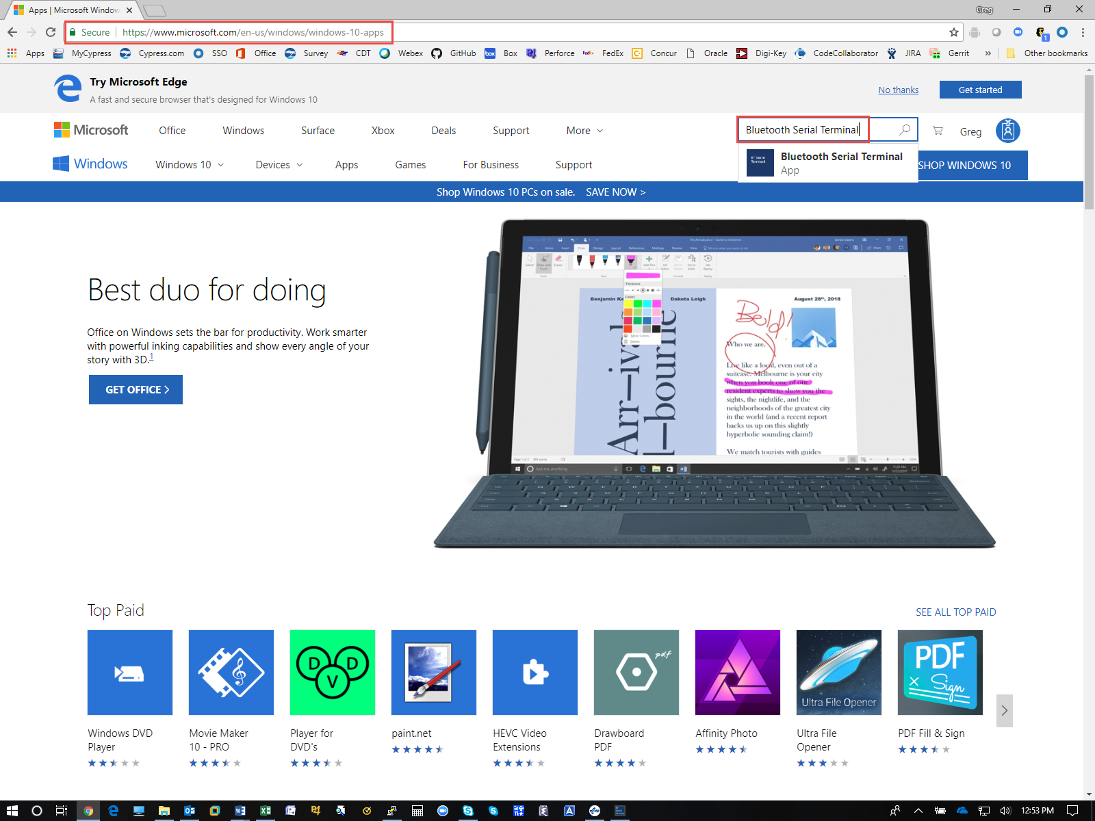

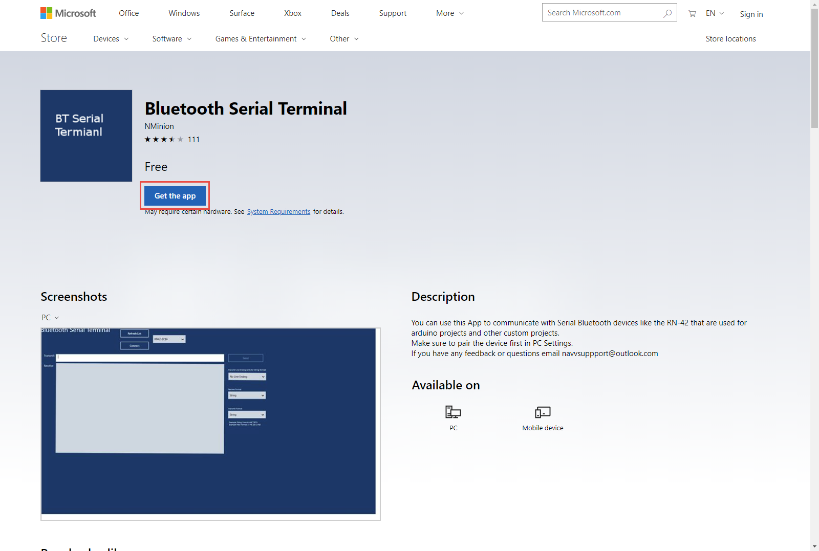

As with Windows 7, you need to pair with your device before it will show up as a serial port. To do this, go to *Settings -> Devices -> Add Bluetooth or other device -> Bluetooth*. When you see your device in the list, click on it. Compare the 6-digit code with the one displayed on your UART terminal. If the two numbers match, click on "Connect". Click "Done". Your device should now show up in the list of devices as "Paired":

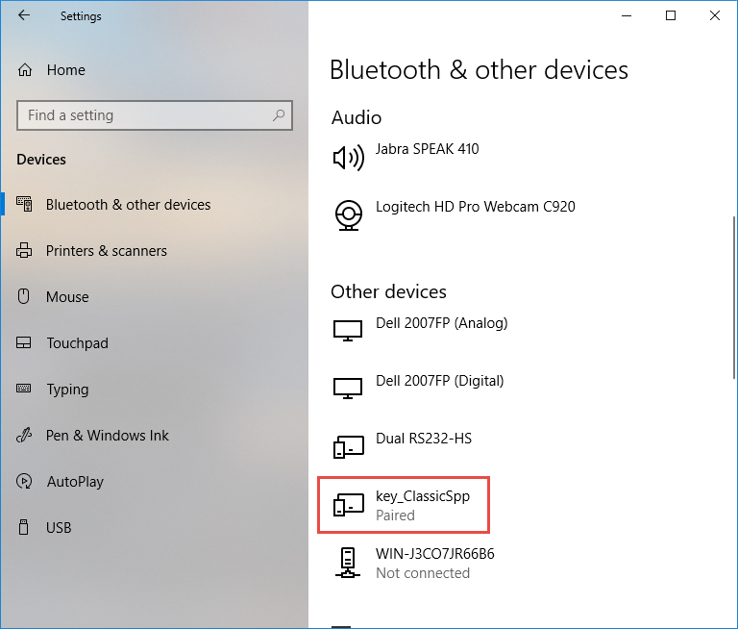

Now open the Bluetooth Serial Terminal app that you installed earlier. Your device should show up in the list. If not click "Refresh List".

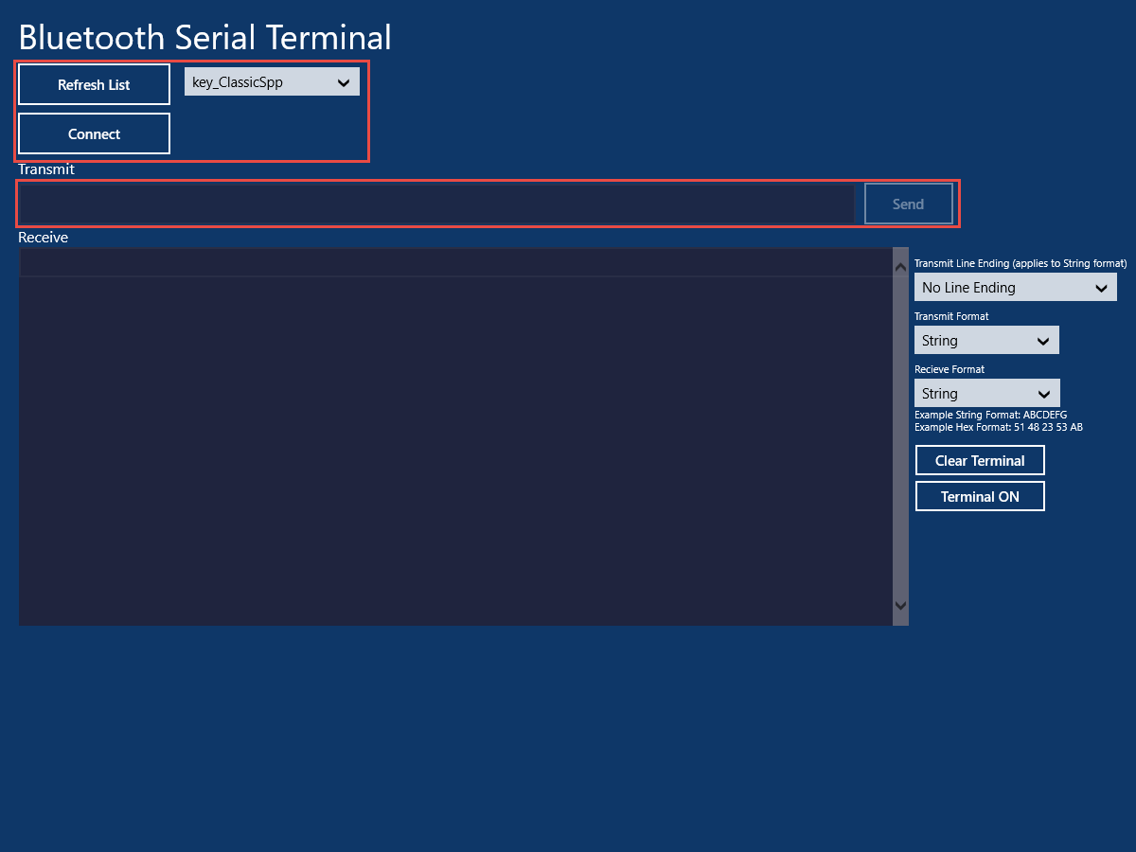

Once you see it in the list, click "Connect". Now you can type strings in the Transmit window and click "Send" to send them to the WICED SPP Project. Observe the strings being received in the WICED kit by watching in the UART terminal.

When you are done testing, click "Disconnect", close the Bluetooth Serial Terminal app and then go into the computer's Bluetooth settings to remove the device's paring information (Settings -> Devices -> <appname>_ClassicSpp -> Disconnect -> Yes).

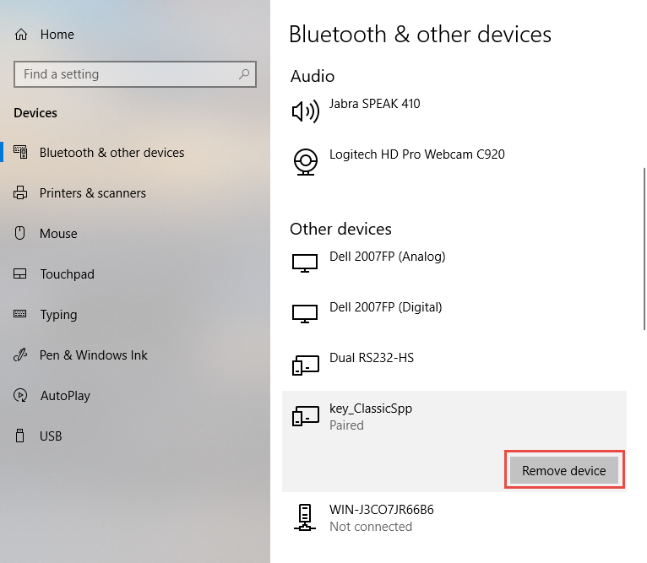

### Android Instructions

On an Android phone, you can install "Serial Bluetooth Terminal" from the Google Play Store. When you run the App, you will need to pair with your development kit. To do that open the menu (3 lines near the upper left corner) and tap on "Devices". From the Devices page, click on the "Gear" icon. This will take you to your phone's Bluetooth settings.

  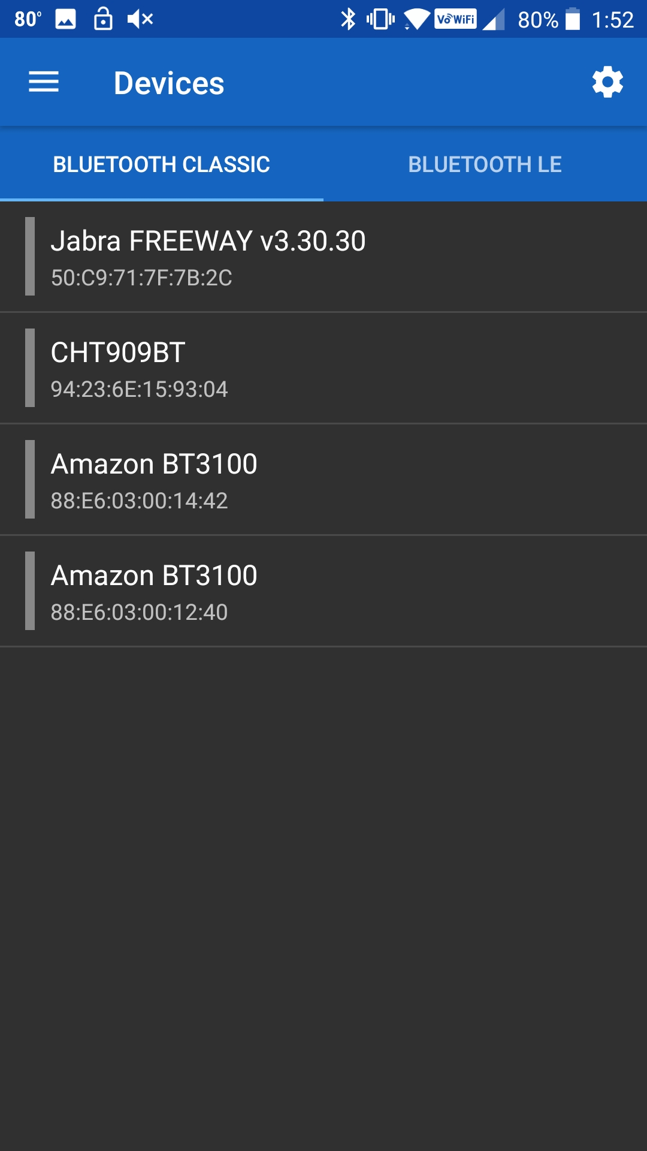

Find your device in the list and Pair with it (the exact procedure may be slightly different depending on the version of Android you are running).

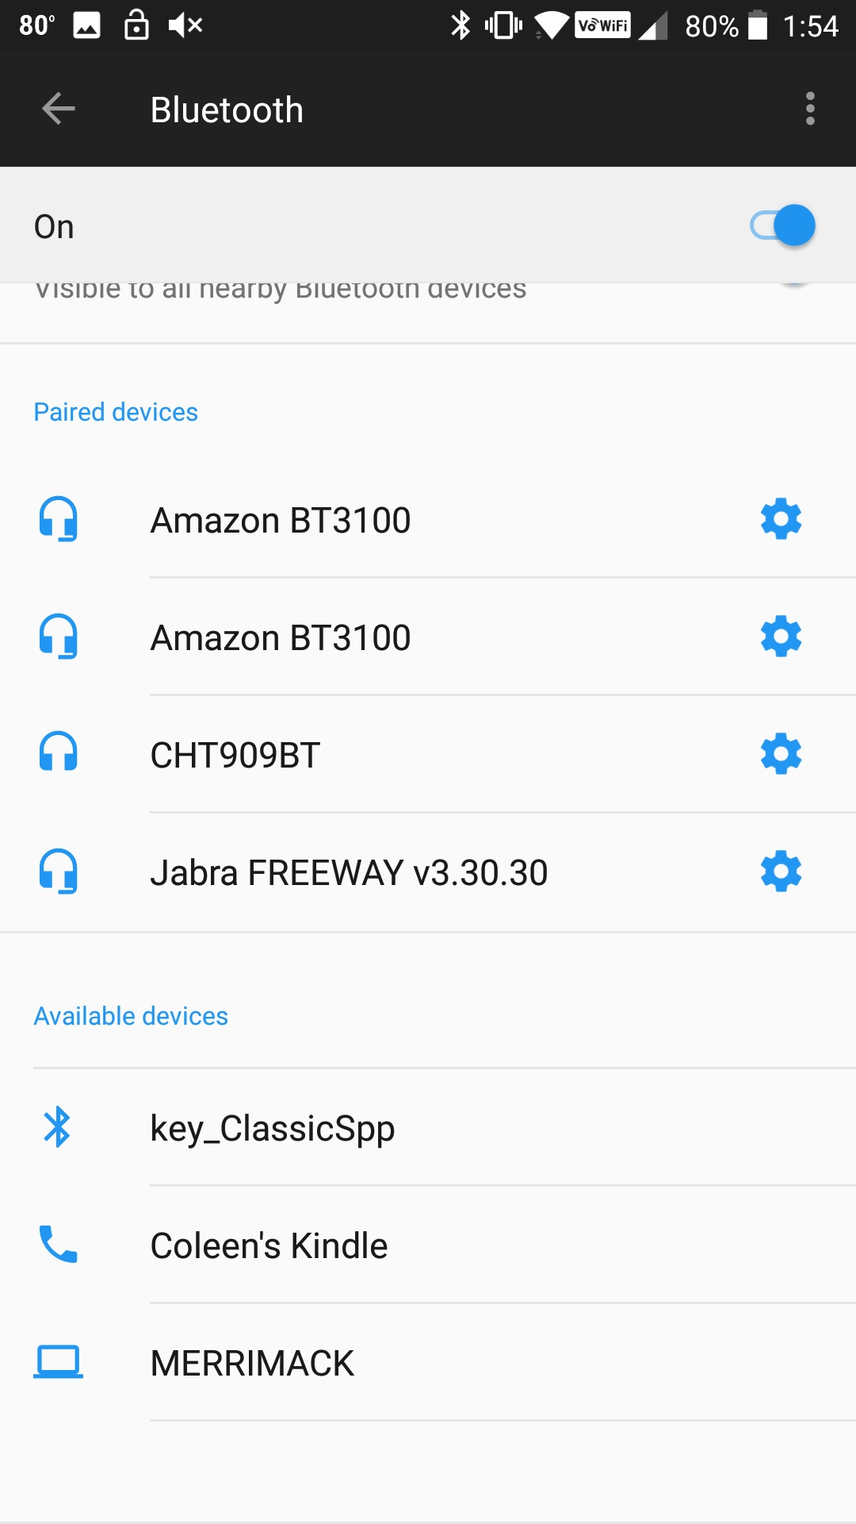 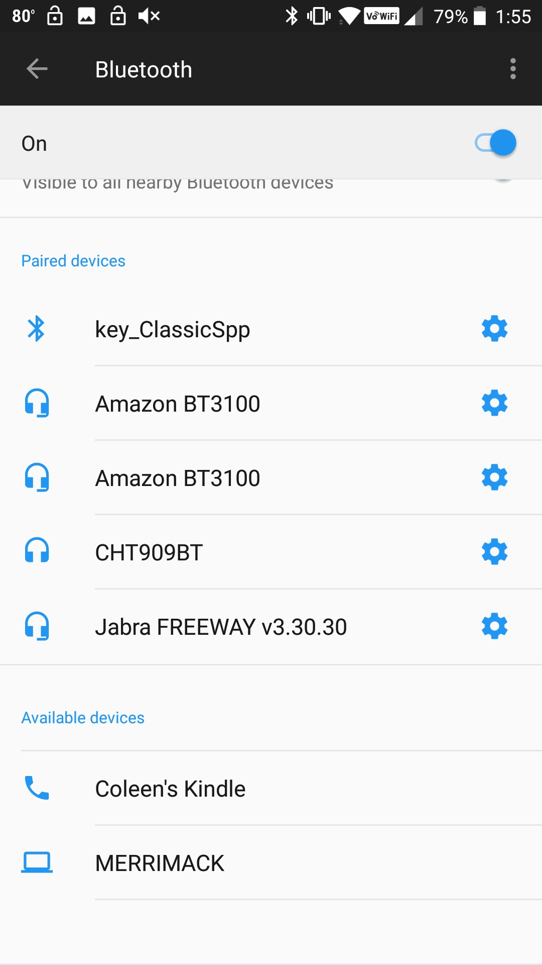

Once the device has been added, press the back arrow and you will see that your device appears in the Devices list. Tap on it to make it the active device (it will have a green bar to the left of the name when it is active). Then open the menu and select "Terminal" to see the blank terminal window. Next, tap the plug icon near the upper right corner to open the SPP server connection to your development kit. It will say "Connected" in the terminal window.

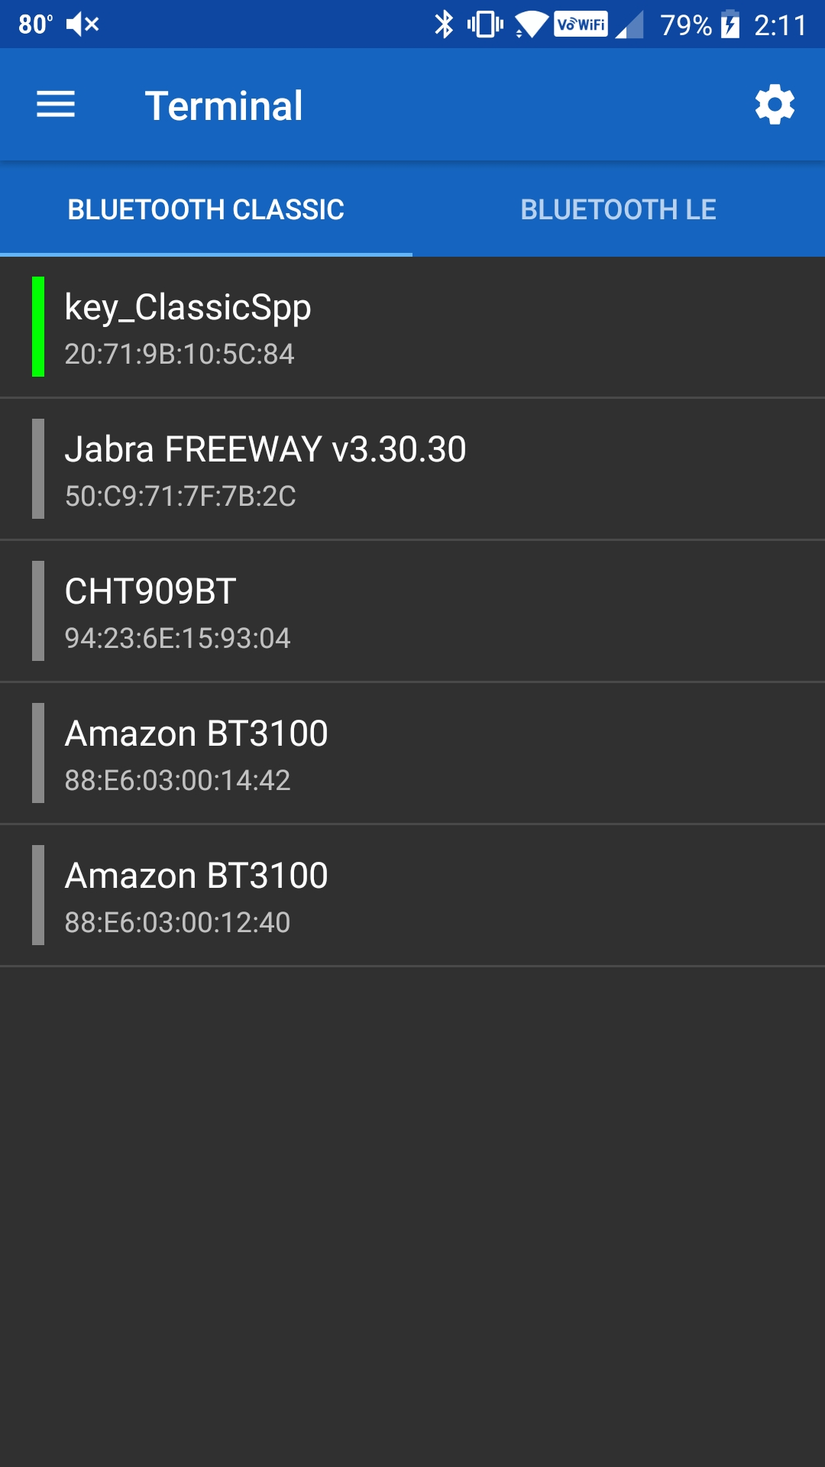  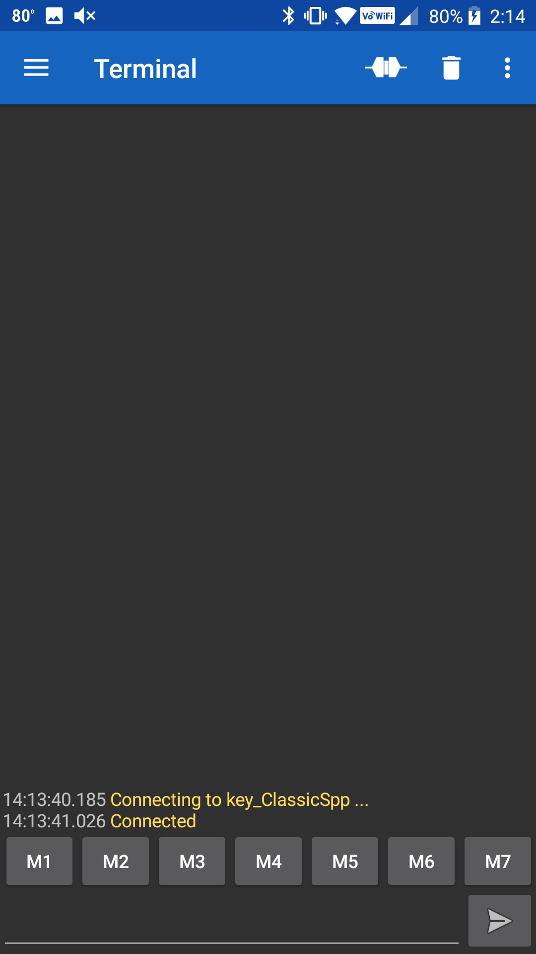

Now you can send data to the SPP server by entering it at the bottom of the window and clicking the Send arrow. You will see the data transmitted on the PUART terminal window for the kit.

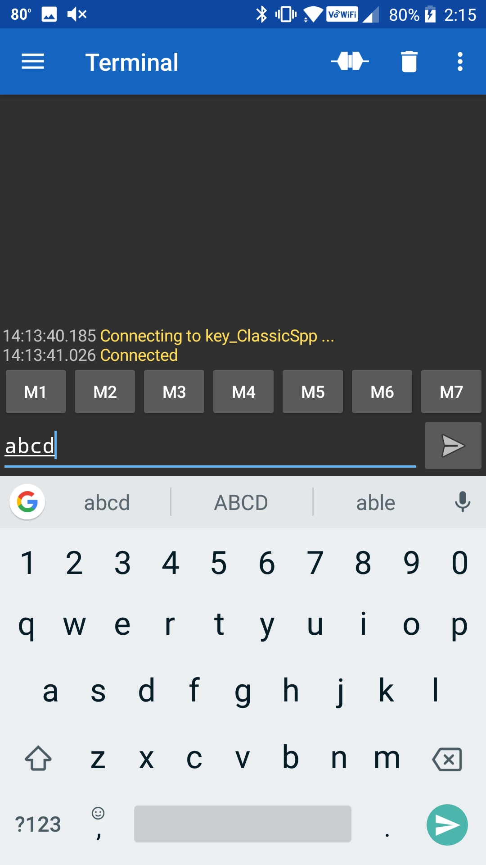 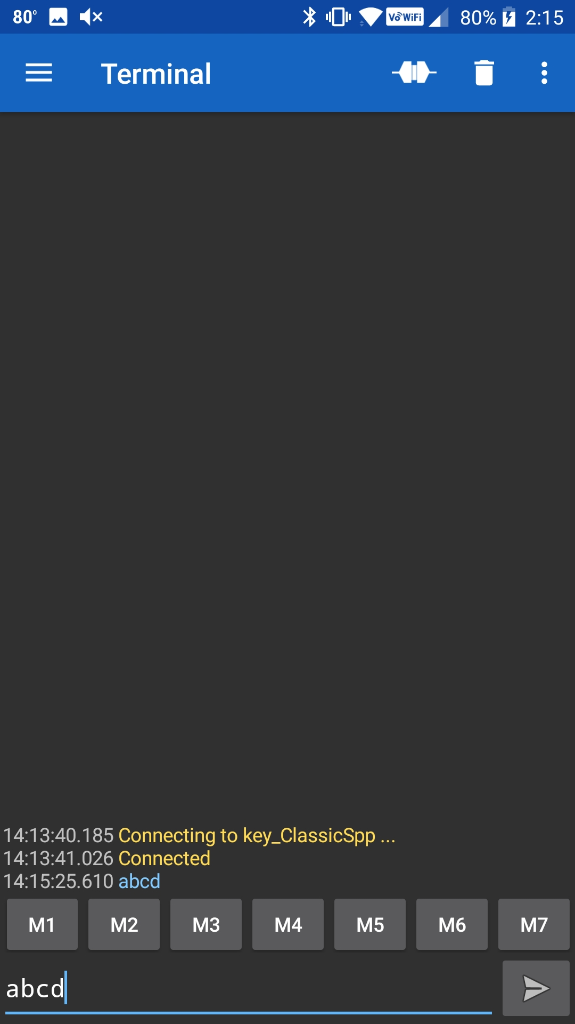

When you press the plug again, it will disconnect. You can then go back to the menu, select Devices, click on the Gear icon, and delete the Bonding information for your device (aka Forget) from the Bluetooth settings. Again, the exact procedure to forget the device will vary based on the version of Android you are running.

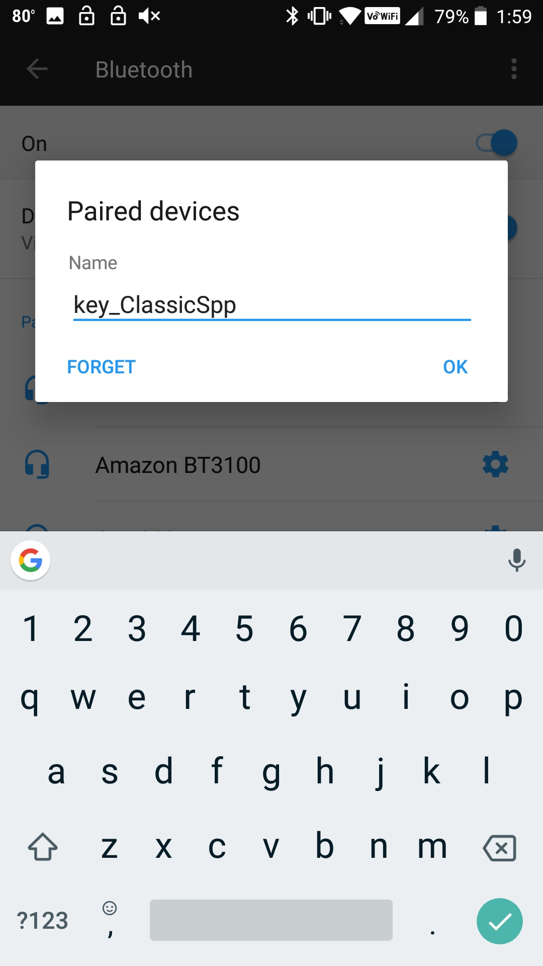

### Mac Instructions

Install "Serial" from Decisive Tactics onto your Mac. You can get it in the App Store.



Once you have programmed the development kit you need to connect to it from the Mac. In the Serial program choose File 🡪 Open Bluetooth.



Then click on your project and press "Select". This will pair to the development kit and open a window.



You will be asked to confirm the connection.



Once it is connected, everything you type will appear in the console window of the WICED Development kit. Below you can see that I typed "asdf".



To unpair your development kit, select the Bluetooth symbol and pick "Open Bluetooth Preferences"



Select your device and click the "X".

You will need to confirm that you want to remove the Bonding information from the Mac BT Stack.



* 1. Add UART Transmit

Make a copy of Exercise - 6A.1 and modify it to include a transmit function so that you can send data in both directions. You will read characters from the PUART terminal window so that when you type keys on your PC keyboard those values will be transmitted over Bluetooth to the Bluetooth Serial window.

Hint: There is an example in the Peripherals chapter that receives characters from a terminal window. Refer to that if you need help determining how to read characters from the PUART.

Hint: Add a new function called *spp_tx_data* to *spp.c* and *spp.h* to send the data. It will take a pointer to the data to send and the length as parameters and will call the *wiced_bt_spp_send_session_data* function to send the data. You will call the *spp_tx_data* function from the main application whenever a keystroke is received from the PUART.

Hint: You can rename the project/files in the new project if desired. If you want to change the name of the device that shows up on the Bluetooth scan, it is inside the file wiced_bt_cfg.c.

* 1. (Advanced) Improve Security by Adding IO Capabilities (Yes/No)

In this exercise, we are going change the previous exercise to add confirmation on the WICED device. As before, a value will be displayed on both ends of the connection (WICED device and the phone or PC). The user will need to compare the two values and then perform the confirmation step on both devices before the connection is established.

Note: the phone may or may not display the value and it may or may not require user input – this is up to the phone application. In the case where the phone automatically confirms the value you will still have to accept the connection on the WICED device end.

You will add the capability for the user to confirm that the numeric comparison value is correct on the WICED device using the two mechanical buttons on the shield to indicate "Yes" or "No".

To make this work you need to:

1. Make a copy of Exercise - 6A.2 and modify it as follows:
   1. Update BTM_PAIRING_IO_CAPABILITIES_BR_EDR_REQUEST_EVT to notify the Master that you have Display and Yes/No capability.
   2. Add code to the BTM_USER_CONFIRMATION_REQUEST_EVT that will turn on the interrupts for the two mechanical buttons and inform the user that they should press the correct button.
      1. Hint: This event will provide the BDADDR for the master that is trying to pair. You should save this value (hint: memcpy) to a global since you will need it when you reply in the interrupt.
      2. Hint: You can use the same callback function for both interrupts – the interrupt passes the port_pin information to the callback function.
   3. When the button interrupt happens send wiced_bt_dev_confirm_req_reply() and then disable the two mechanical button interrupts. Look at the function declaration to determine what information you need to send with the reply based on which button was pressed.
      1. Hint: Make sure you remove the existing wiced_bt_dev_confirm_req_reply() call from the BTM_USER_CONFIRMATION_REQUEST_EVT.

Hint: You can rename the project/files in the new project if desired. If you want to change the name of the device that shows up on the Bluetooth scan, it is inside the file wiced_bt_cfg.c.

* 1. (Advanced) Add Multiple Device Bonding Capability

In this exercise, you will add the capability to store bonding information from multiple devices. You will need to make two changes to your current SPP implementation:

1. Handle saving multiple link keys into the NVRAM. Let's use 8 for the maximum number of saved link keys. Use one VSID to save a one-byte count of how many are being used. Then use VSID = VSID_Start+count to save each additional Address/Key Bonding pair.
2. Handle reading multiple link keys. When you get the event BTM_PAIRED_DEVICE_LINK_KEYS_REQUEST_EVT, the event data will be a pointer to a wiced_bt_device_link_keys_t structure. That structure contains the BDADDR of the device that is trying to pair. You need to search through the VSIDs to find the BDADDR of the saved link keys. If you find one that matches return it. Otherwise return a WICED_ERROR so that a new device can be added.

Hint: You can rename the project/files in the new project if desired. If you want to change the name of the device that shows up on the Bluetooth scan, it is inside the file wiced_bt_cfg.c.

Once you have the project completed, try bonding with two different devices (e.g. phone and PC). Connect and disconnect back and forth to verify that bonding information for both is retained and is used when reconnecting.